NEWS & VIEWS No 200 February 2025
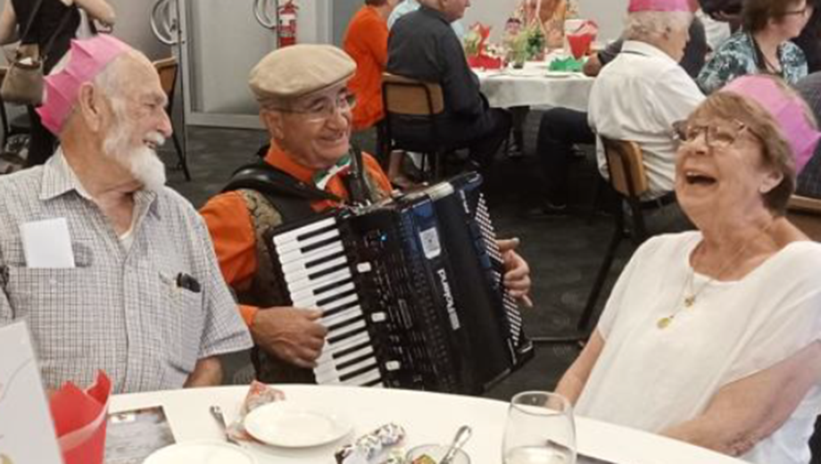

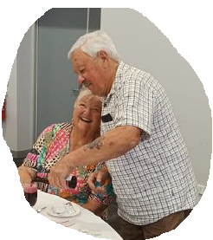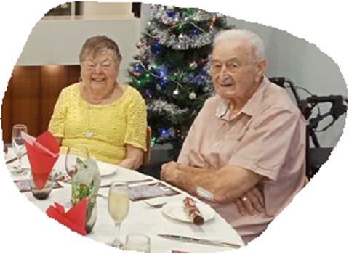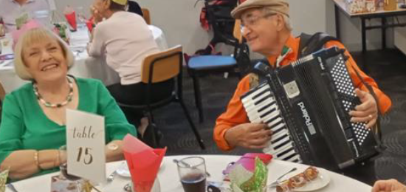
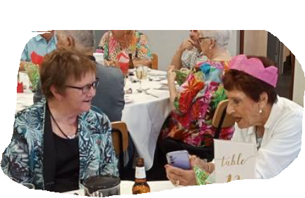

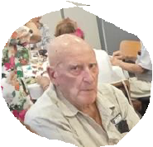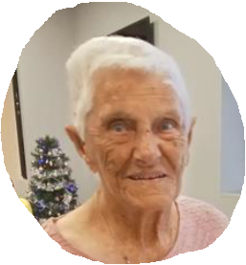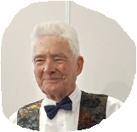

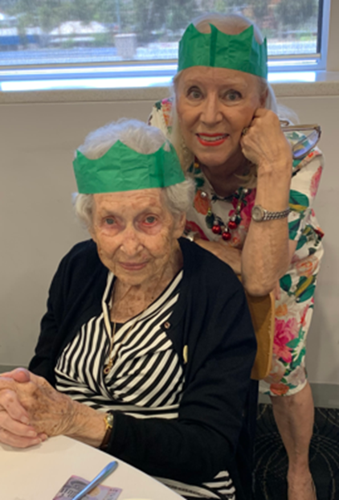

16th STATE FRIENDSHIP CARNIVAL 2025

HOSTED BY SOUTHERN BRANCH BOWLS PAST PRESIDENTS ASSOCIATION
ALL GAMES ARE OPEN GENDER FOURS

Monday 7th April
Play commences 9.00am for photos. 10am Start
Encounter Bay Bowling Club

Tuesday 8th April
Play commences 9.30am for 10am Start
Goolwa Bowling Club

Wednesday 9th April Rest Day State Delegates Meeting

Thursday 10th April
Play commences 9.30am for 10am Start
Port Elliot Bowling Club

Friday 11th April 9.30am for 10am Start
Victor Harbor Bowling Club

PRESENTATION DINNER

Friday 11th April Victor Harbor Bowling Club 6.30pm for 7pm
Gents – Business shirt & slacks – Ladies Casual dress
Denim & Bowls attire not acceptable
Drawing of the Raffle

Branch President - Colin Eckert
Bowls Past Presidents Association of SA Inc.
Southern Branch
CONDITIONS OF PLAY
- Play will be conducted under the Laws of the Sport of Bowls
- The Carnival will be conducted over eight games of 12 ends
- The Carnival Committee reserves the right to terminate a game that is over time
- Games will commence strictly at 10.00am and 1.30pm
- Players are required to arrive at the venue 30 minutes prior to the starting time
- Team Captains are required to pay for the Team lunches ($25.00 per player) at the time of morning registration
- Roll up ends are NOT PERMITTED
- NO DEAD ENDS: re-spot the jack on the center line 2m mark
- Two points will be awarded for a game win and One point for a drawn game
- Winners will be decided by :-
- The team scoring the most points. If scores are tied:-
- Shots up. If score still tied:-
- Percentage
- In the case of a forfeit, the team receiving the forfeit will be awarded two points plus 8 shots
    - All players must be financial members of the Bowls Past Presidents Association
- Players are required to wear the Association shirt or a plain white shirt
      - Club pants/dress acceptable. Interrupted play
- In the event of rain or other unforeseen delays: Results of the game shall be determined by the Carnival Committee
- The Heat Policy of the Association is to apply in all cases: - Play will be stopped and may be cancelled if the temperature at the daily venue reaches 38 degrees.
- A progress Result Chart will be displayed daily after day one.
- PRIZES
- Overall Winning Team after 8 games $500.00 per player

Overall Runner up Team after 8 games $250.00 per player
Overall Third Team after 8 games $120.00 per player
Best Performed Team on each day $50.00 per player
ANY TEAM MAY ONLY WIN ONE OF THE BEST PERFORMED PRIZES LISTED ABOVE

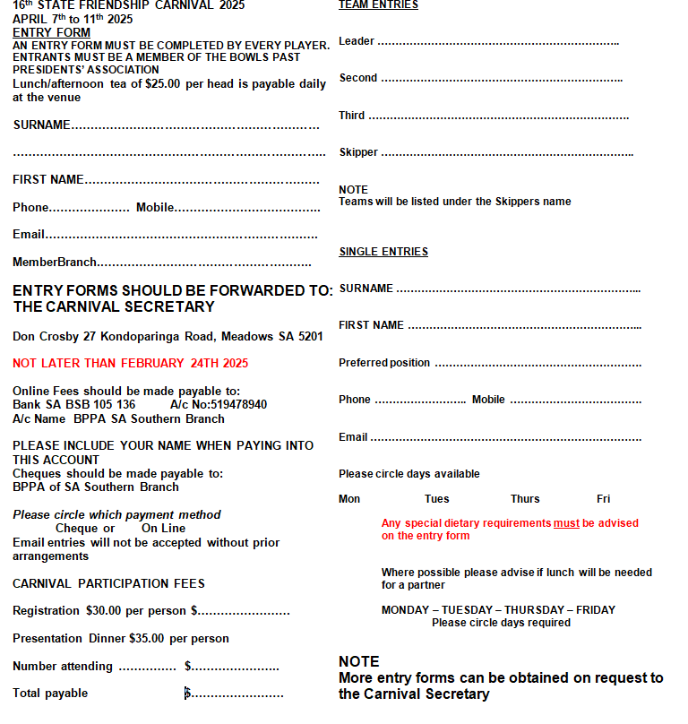

HILLS & LOWER MURRAY BRANCH SOCIAL DAY
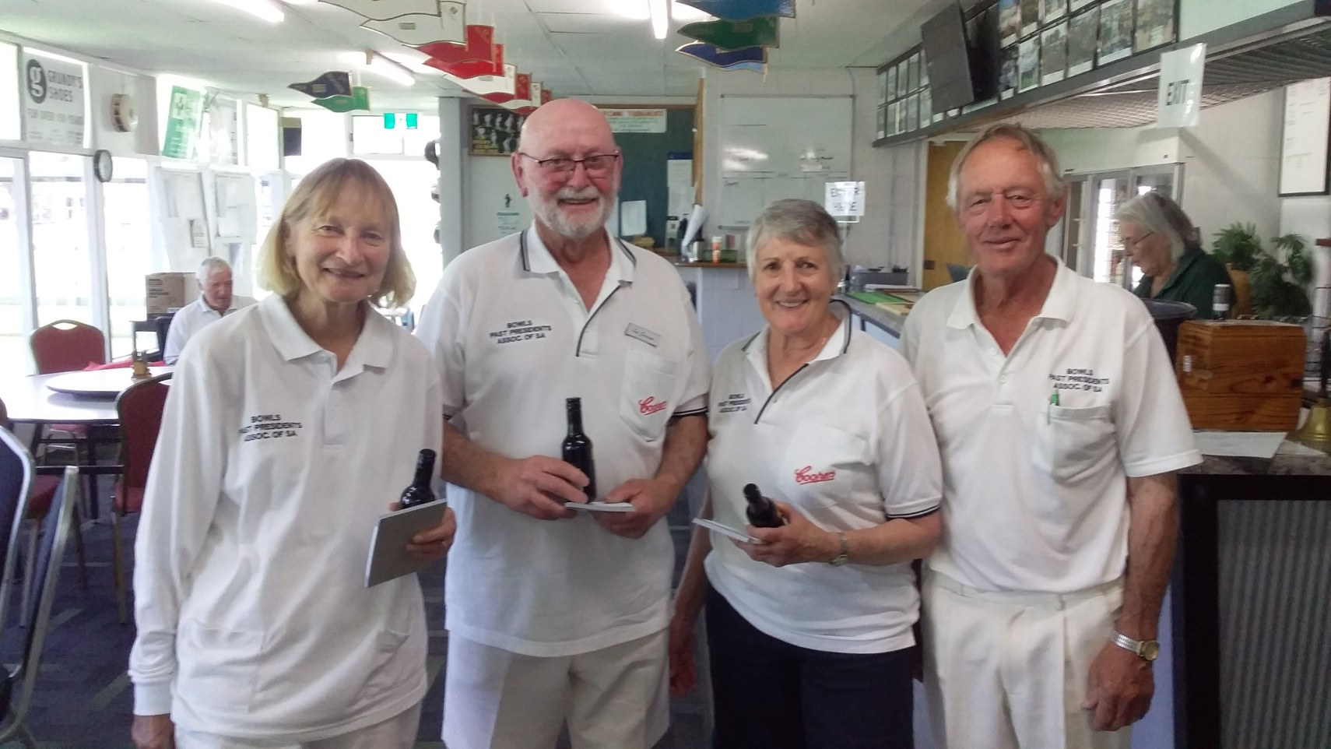
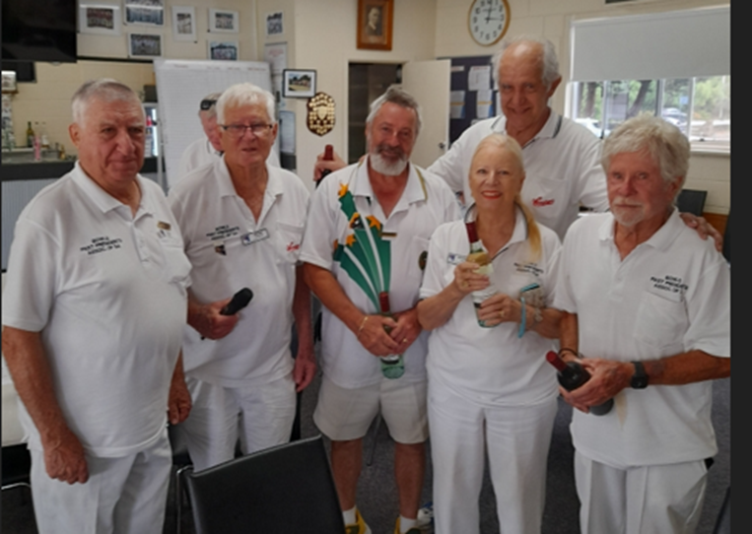
An enjoyable day was spent down by the river at the Mannum B.C. where we played bowls on Monday 14th Oct. The club hosted Past Presidents, Associates & Social members for the day.
This was our 1st internal game for about 2 years. We had 30 bowlers on the green playing three bowl triples of two games.
A lovely two course meal was provided by the Mannum B.C.
The weather was reasonably kind to the bowlers, but with some light rain at times, as this did not dampen the spirits of the keen ones.
There were only 2, two game winners on the day, but the winners for the day were
Sas Scown, Lyn Harten 2nd Lenny Gommers Sk.
Shown with President Brian Scown Winning by a margin of 4 shots.
Runners up were S.Morten B.Kirchner.B.Scown.
We had six new social members join today.
LOWER SOUTH EAST BRANCH - SOCIAL DAY
What a beautiful day out visiting Mt Gambier Aquifer Tour at the Blue Lake led by our guide Gary in the colourful shirt. He had so much knowledge to share as it was his passion. He had us walking down through a tunnel then a lift down to be level with the lake's pumping station and then the hard walk back up the hill. Slow and steady wins the race. We all made it. We then hopped back in our cars drove to Pt McDonnell for a visit to the magnificent Maritime Museum where we were met by a team of very enthusiastic volunteers sharing their local knowledge and a nice hot cup of coffee (tea for some) and biscuits. After a leisurely walk around this beautifully presented structure housing not only the Museum but also a Visitor centre and a Gem Gallery, Library and so much more. After all this what better way to finish a great day out but to go to the Pt McDonnell Hotel for a delicious lunch where several more of our Past Presidents joined us.

Ella Pietersma
Secretary Lower South East Branch
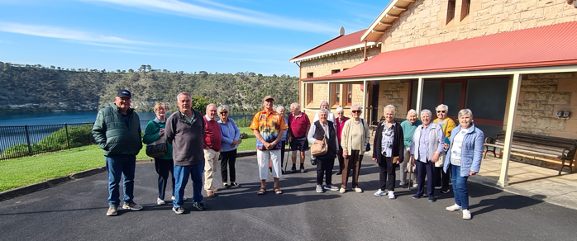
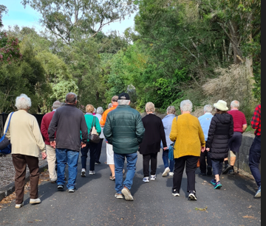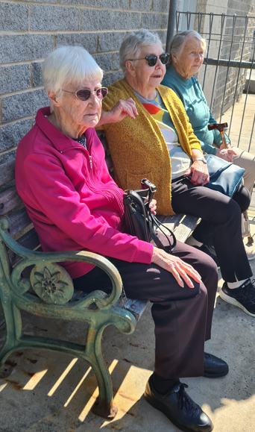
SOUTHERN BRANCH - OPENING/CHARITY DAY

On the 21st September the Southern Branch held their Open/Charity Day.
After some short speeches SA President, Don Crosby, declared our season open and bowlers made their way onto the green. A warm, windless overcast day greeted the bowlers as they prepared to play the first of 12 ends.
At the lunch break Brian Patterson was inducted as a member of Southern Branch and a cheque for $500 was presented to Representatives from Riding for the Disabled.
After lunch players returned to the green for a further 12 ends of bowls. Once done bowlers returned to the clubrooms for the formalities to end the day.
Our thanks to Christies Beach Bowling Club for hosting the day and providing excellent greens.
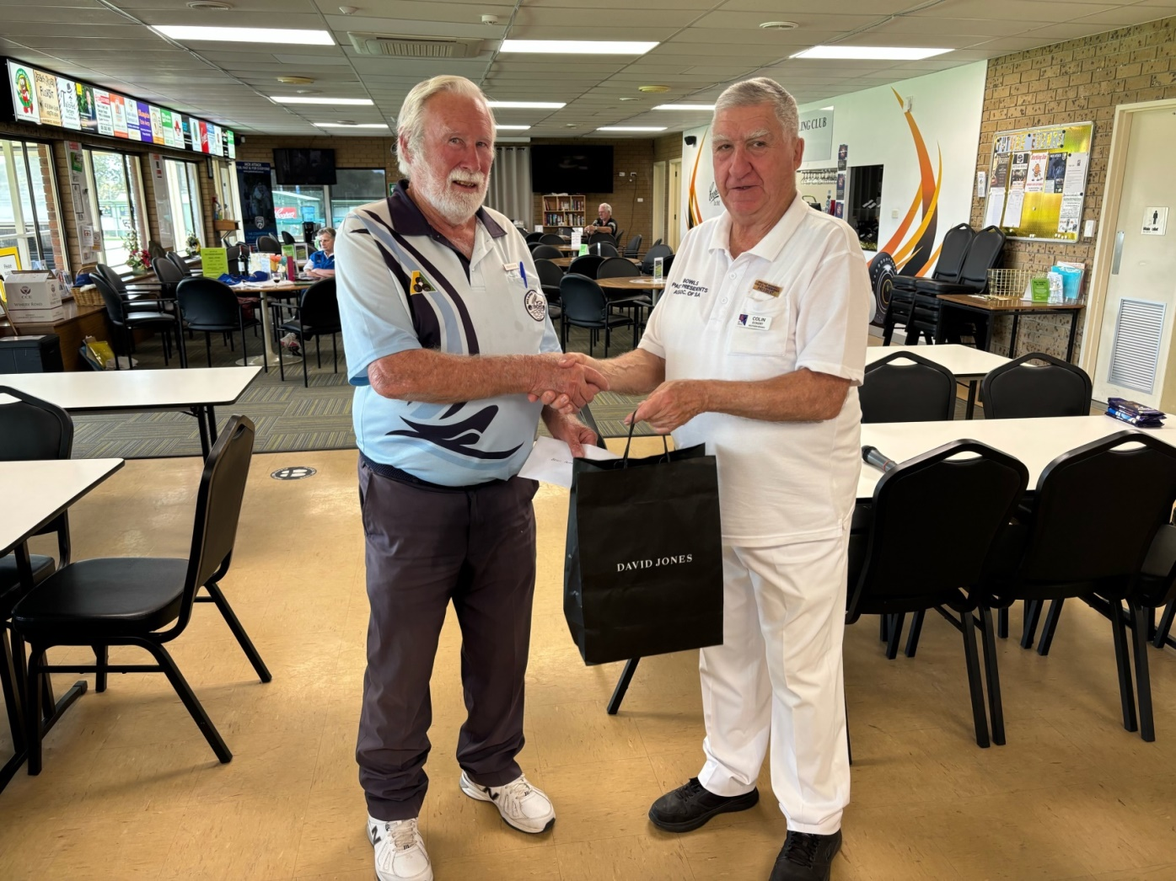
Brian Patterson is welcomed as a Member by President Colin
President Colin Eckert presents a cheque to representatives of the Riding For Disabled Charity
. 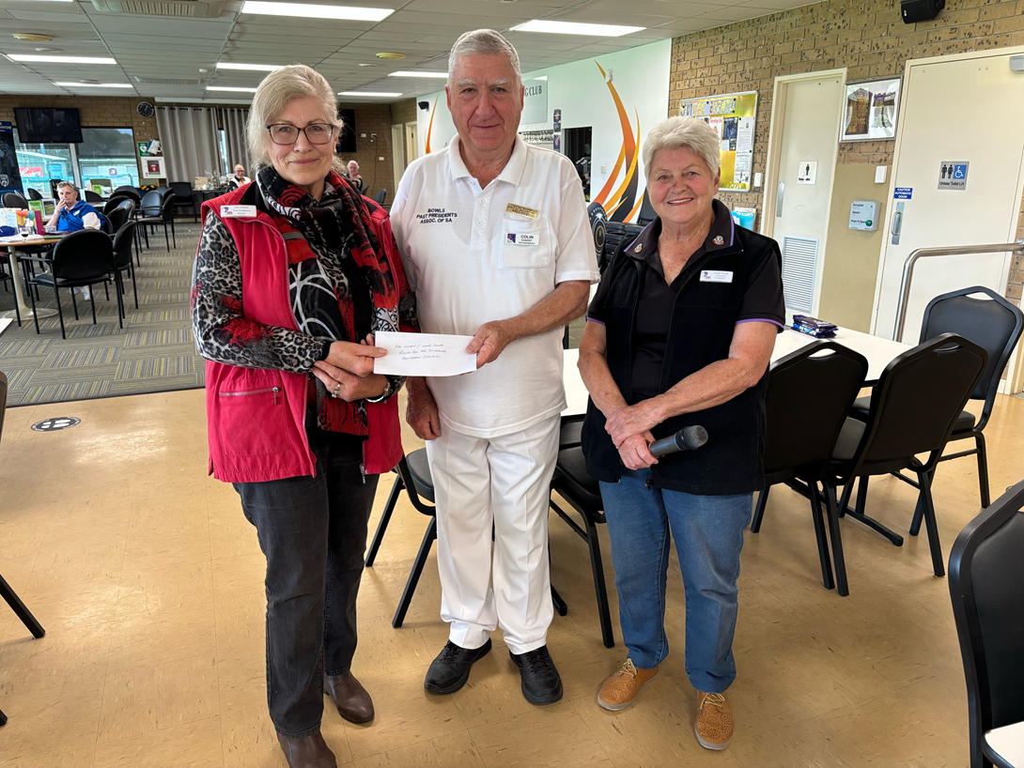
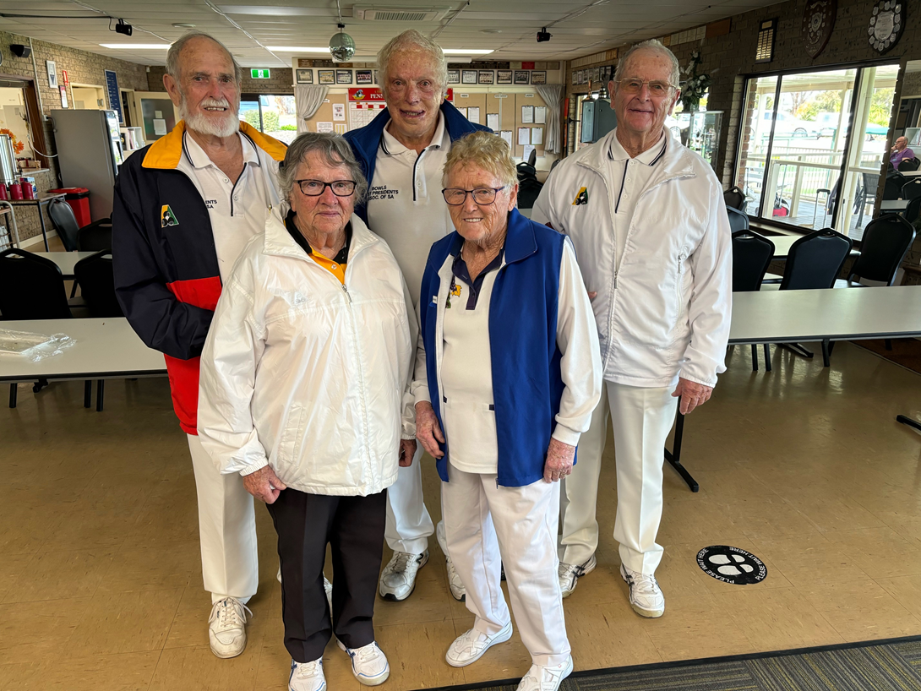
Afternoon winners from left to right
SA President Don Crosby, Eleanor Burge,Laurie Rowley, Southern Games Manager, Marie Broadwood, Barry Troughbridge

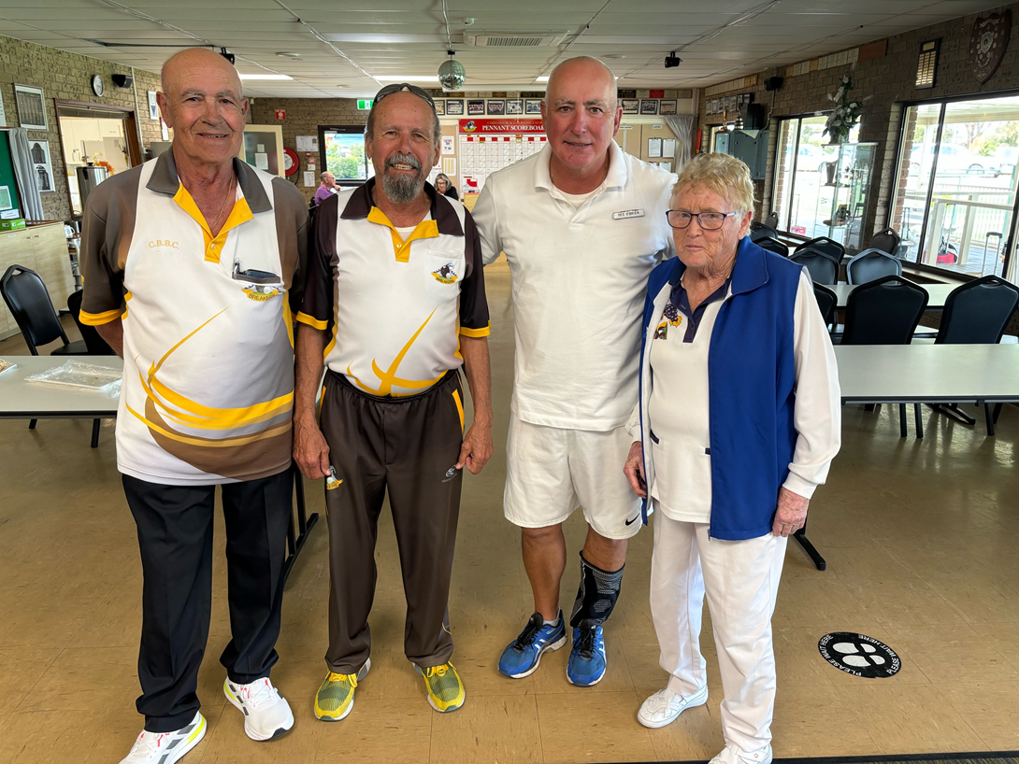
Morning winners left to right
Eddie, Hodgy, Des O’Brien and Zsolt (unavailable) with Games Manager Marie Broadwood.

LOWER SOUTH EAST BRANCH
Day at Naracoorte RSL
This game was played in ideal conditions with the winners being

Esther Scudds, Mary Clifford, Margaret Marshall and Alby McIntyre.

25 players had lots of and competition on their new green. It was nice to go for a little walk at lunch time to the Naracoorte Hotel then walk back to resume the last game before the winners were announced and the raffle drawn. We are all now looking forward to our Social day in four weeks time to the Aquifer Tour in Mt Gambier, and the Maritime Museum at Pt McDonnell followed by a visit to the Bellum Hotel.
Ella Pietersma

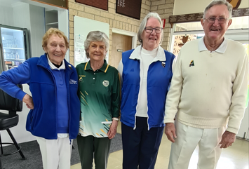

Alby McIntyre winning a piece of Pork in the Raffle. having a good day.

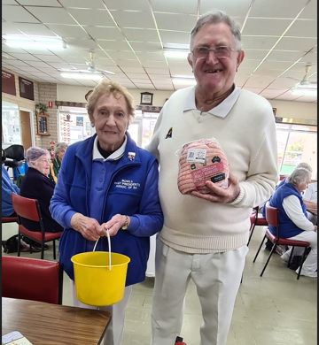

BRANCH CONTACT DETAILS
PLEASE NOTE THESE DETAILS ARE ALSO LISTED ON OUR WEBSITE

Please report changes to Officials promptly to Editor Don Priestley so this section and the website can be kept fully up to date

EYRE PENINSULA BRANCH
President Graham Kenny mob: 0437 418 697 email: jankenny1@hotmail.com
Secretary Cyril Hier 38 Harvey Drive Tumby Bay 5605
mob: 0437 882 407 email: cyrilhier@gmail.com

HILLS & LOWER MURRAY BRANCH
President Brian Scown ph:8389 7272 mob: 0407 597 244 email: Brianscown3@gmail.com
Secretary Wayne Lee 1 Liverpool Drive, Strathalbyn 5255
ph: 8536 8971 mob: 0408 816 525 email: wle04468@bigpond.net.au
Games Officer Kevin Schulz PO Box 7, Charleston 5244
ph:8389 4302 mob: 0418 803 294 email: kevinshulz@bigond.com

LOWER NORTH BRANCH
President & Games Manager Brian Eime mob:0417 836 882 email:bemveime@gmail.com
Secretary Allan Chivell ph:8862 1483 mob: 0408 495 076 email: achivell@rbe.net.au

LOWER SOUTH EAST BRANCH
President Robin Bilney mob:0429 021 882 email:j_r_bilney@bigpond.com
Secretary Ella Pietersma ph: 0417 872 317 email: ellapietersma38@gmail.com
Games Manager Jane Crowder ph: 0428 036 682 email : pouchy57@outlook.com

METROPOLITAN BRANCH
President Brian Cookson mob 0438 161 005 email: brianjcookson@hotmail.com
Secretary Patricia Yarham mob:0428 807 915 email:bhoney@bigpond.net.au
Treasurer Kel Waters mob: 0419 830 989 email: kelvinrwaters@gmail.com
Games Manager John Ludbrook ph: 8522 7765 mob: 0498 465 487 email: luds1@live.com

SOUTHERN BRANCH
President Colin Eckert mob: 0467 660 766 email: ecksfactor2@gmail.com
Secretary Treasurer Phil Clifford mob 043 9840 918 email: tottenham50@live.com.au
Games Manager Marie Broadwood mob: 0408 649 341 email: marie.jb@bigpond.com

YORKE PENINSULA BRANCH
President Jim Burgess mob: 0417 814 348 email:jamesburgess5570@gmail.com
Secretary Geoff Male mob: 0417 820 470 email: coppercoastagn1@bigpond.com
Games Manager Vacant (Refer to Secretary Geoff)

STATE EXECUTIVE MEMBERS CONTACT DETAILS ARE LISTED ON OUR WEBSITE
“Bowls Past Presidents SA”

