NEWS & VIEWS No 203
NOVEMBER 2025

CHRISTMAS LUNCH

Due to rising costs and dwindling attendance there will not be an official Christmas Lunch this year.

However, members of the State Executive and friends will be gathering for an informal lunch at Club Marion on NOVEMBER 30TH at 12.30pm. All members are invited to join us there.
The menu will be at your own choice and cost.

We need to inform Club Marion of numbers attending, so if you intend to join us please advise Secretary Kaye no later than FRIDAY NOVEMBER 21ST
Tel : 0407 619 504 email : kayeandbarrywakefield@gmail.com

======+++++++++++++++++++++++++++++++++++++++++++++++++++++

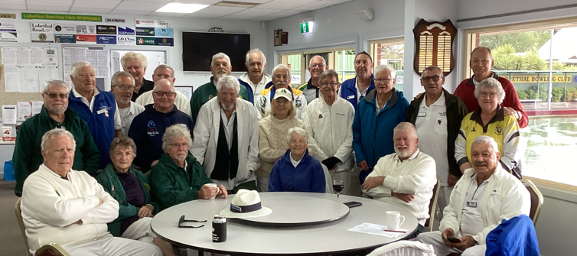

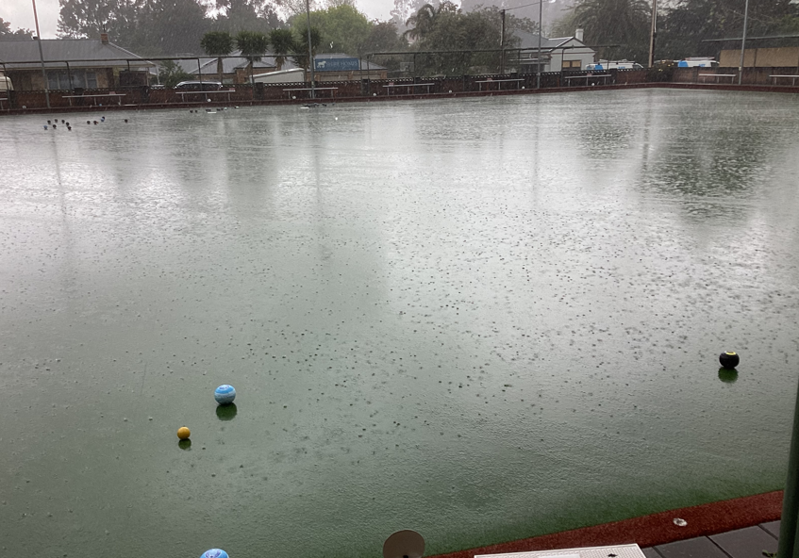

SUNDAY 12TH OCTOBER WAS A CALM , SUNNY DAY. IDEAL FOR METRO'S OPENING DAY AT NOVAR GARDENS SPORTS CLUB. PRESIDENT KEITH DEHEY WELCOMED PLAYERS TO THE MORNING OF TRIPLES AND PAIRS. WHAT A GREAT DAY FOR BOWLS!
At the free lunch of BBQ (cooked by volunteers), salads and ice-creams, Keith thanked the president of Novar Gardens, Jonathan Giddings, for accommodating us and introduced the current committee. With the drawing of the raffle of healthy addictive items, we continued the hospitality of the club with pétanque players.
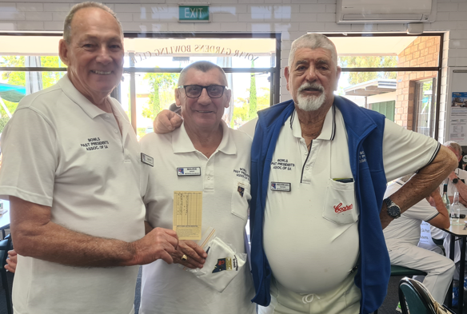
Winners for the day were the team of Keith Dehey, Maurie Davey and Kel Waters

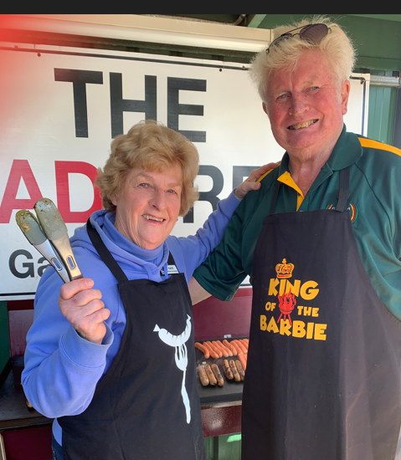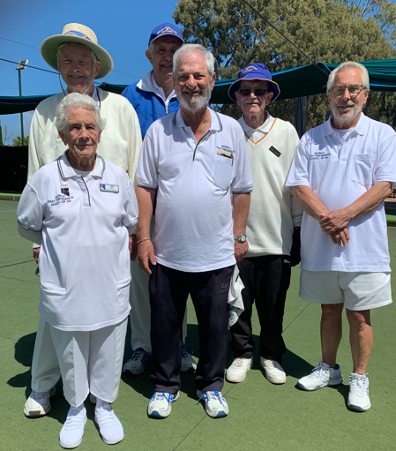

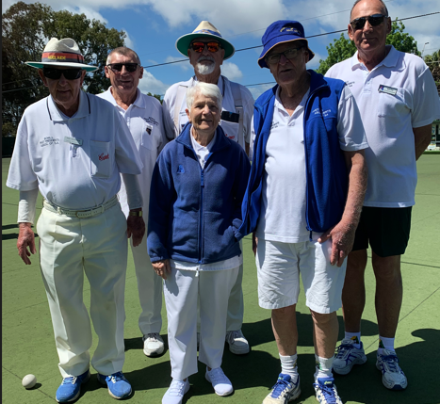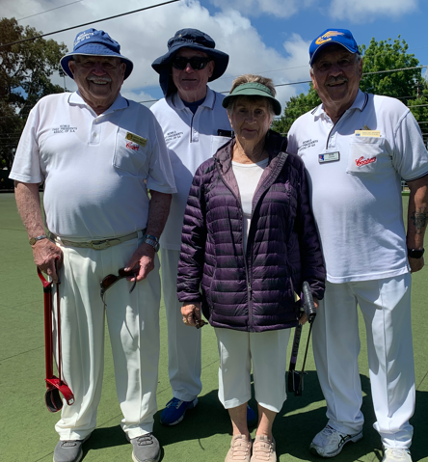

New Committee are:
President Keith Dehey
Secretary Patricia Yarham
Treasurer Kel Waters
Committee Jan May and Brian Cookson

Report by
Brianjcookson@hotmail.com, additional pics by Patricia

Metropolitan Branch has a game against Southern Branch on Mon November 24th at Ascot Park
9.30am for 10

Also against the Police Association on Thursday January 15th at Novar Gardens starting at 7pm

SOUTHERN BRANCH OPEN DAY.

On Monday 22nd September the Southern Branch of Bowls Past Presidents held its Opening Day at the Yankalilla Bowls Club,
Thirty two bowlers took to the greens for a day of fun and friendship. Two games of bowls were played, a morning and afternoon session, with a delicious lunch prepared by the ladies of Yankalilla separating them.
The Open Day has always been about raising money for a charity, and the lunch break a cheque for $500 was presented to Aaron Eckermann, representative from The Leukaemia Foundation.

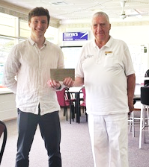
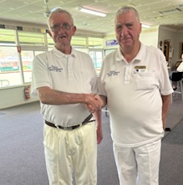

Aaron receiving the $500 cheque Jim Scott is inducted into the Association
From President Colin

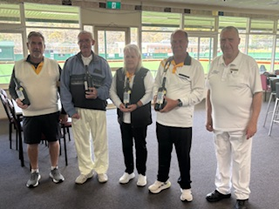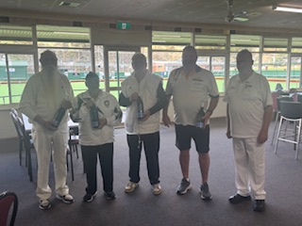

President Colin congratulates Jim Scott’s team and Brian Thompsons team for the afternoon one
as winners of morning session.

THE LOWER SOUTH EAST BRANCH IS ABOUT MUCH MORE THAN BOWLS,
IT’S A THRIVING SOCIAL CLUB

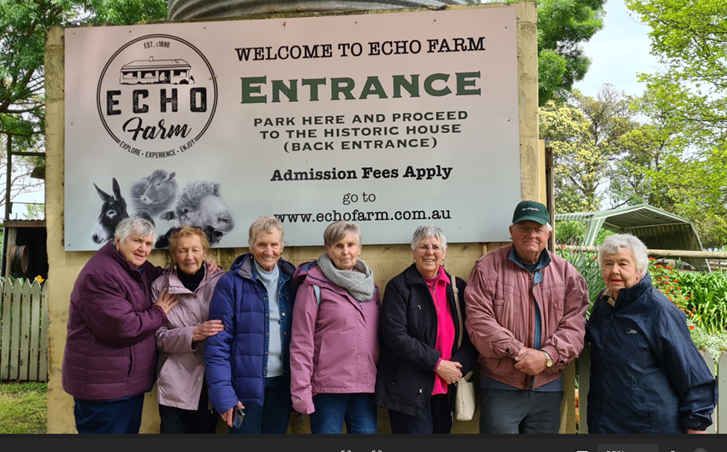

The Lower South East Branch of the Past Presidents enjoyed our Social day out at the Echo Farm in Mount Gambier on the 27th September with a morning tea and a self guided tour feeding all different kind of animals who were all very tame and obviously had a lot of tender loving care.
This was followed by a lovely lunch together at the Park Hotel.
It was nice to meet up together again as the next time will be our Christmas lunch at Kalangadoo being the last activity this year.
Secretary Lower South East Branch
Ella Pietersma.

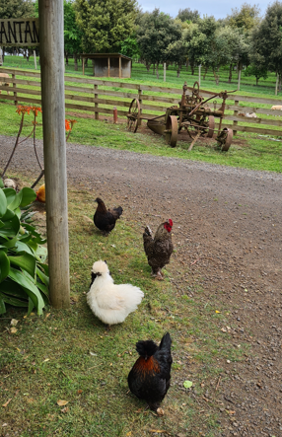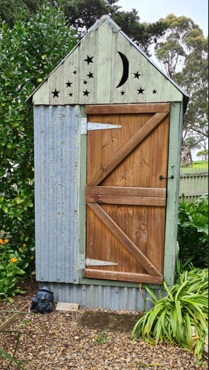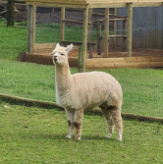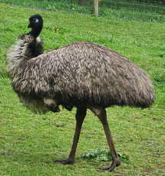

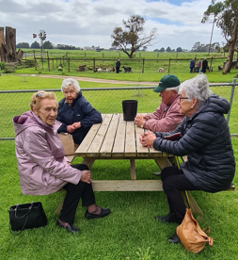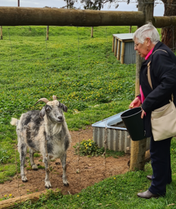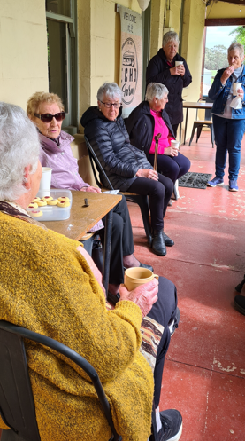

==============================================================
OUR COVER PICTURE

METRO BRANCH v HILLS & LOWER MURRAY 3rd November

Metro past presidents ventured to Lobethal bowling club to play Hills & Lower Murray . The weather unfortunately was not great with rain delaying play and eventually causing a halt to play completely
Sixteen players (in pooled cars) ventured through the green country side.

Play finally started about 10.45 and we ventured onto the green and played a few ends before rain halted play. With rain delaying play again it gave the club the opportunity to sell more lottery tickets. Just as it looked as though we might be able to play more bowls the rain came down once again.
The games managers got their heads together and called early lunch.

Lunch was chicken schnitzel with plenty of salad topped off with apricot slice and ice cream. All thoroughly enjoyed by all.

Unable to get back on the green we drew the raffle early and said our thanks.
We made a loose commitment to finish the game at a later date at the same venue on a date to be announced later.
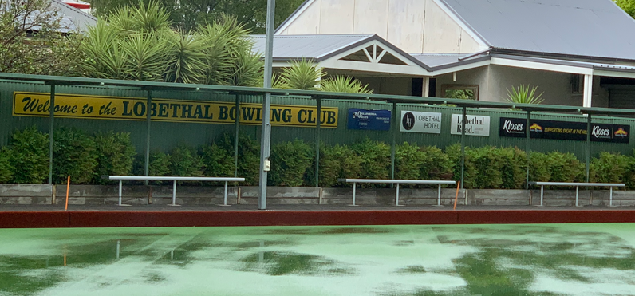

27TH NATIONAL FRIENDSHIP CARNIVAL
BUNDABERG QLD.
SUNDAY 19TH APRIL to FRIDAY 24TH APRIL 2026

It is not likely that the South Australian Association will muster enough entries this time to enable us to consider a long bus trip as we did in in 2010.

However, if there are enough Members interested in travelling to the Carnival, it might be possible to organise some sort of group travel to get there.

If you wish to simply register your possible interest at this stage, please contact State Secretary Kaye Wakefield
email: kayeandbarrywakefield@gmail.com
so we have some idea as to whether or not it is worth our worthwhile to consider it further.

BRANCH CONTACT DETAILS
PLEASE NOTE THESE DETAILS ARE ALSO LISTED ON OUR WEBSITE
“ Bowls Past Presidents SA”

Please report changes to Officials promptly to Editor Don Priestley so this section and the website can be kept fully up to date

EYRE PENINSULA BRANCH
President Graham Kenny mob: 0437 418 697 email: jankenny1@hotmail.com
Secretary Cyril Hier 38 Harvey Drive Tumby Bay 5605
mob: 0437 882 407 email: cyrilhier@gmail.com

HILLS & LOWER MURRAY BRANCH
President Brian Scown ph:8389 7272 mob: 0407 597 244 email: Brianscown3@gmail.com
Secretary Wayne Lee 1 Liverpool Drive, Strathalbyn 5255
ph: 8536 8971 mob: 0408 816 525 email: wle04468@bigpond.net.au
Games Officer Kevin Schulz PO Box 7, Charleston 5244
ph:8389 4302 mob: 0418 803 294 email: kevinshulz@bigond.com

LOWER NORTH BRANCH
President & Games Manager Brian Eime mob:0417 836 882 email:bemveime@gmail.com
Secretary Allan Chivell ph:8862 1483 mob: 0408 495 076 email: achivell@rbe.net.au

LOWER SOUTH EAST BRANCH
President Robin Bilney mob:0429 021 882 email:j_r_bilney@bigpond.com
Secretary Ella Pietersma ph: 0417 872 317 email: ellapietersma38@gmail.com
Games Manager Jane Crowder ph: 0428 036 682 email : pouchy57@outlook.com

METROPOLITAN BRANCH
President Keith Dehey mob: 0488 026 862 email: cornelisdehey@gmail.com
Secretary Patricia Yarham mob:0428 807 915 email:bhoney@bigpond.net.au
Treasurer Kel Waters mob: 0419 830 989 email: kelvinrwaters@gmail.com

SOUTHERN BRANCH
President Colin Eckert mob: 0467 660 766 email: ecksfactor2@gmail.com
Secretary Treasurer Chris Lewis, mob:0458 509 691 email:cmellewis@bigpond.com
Games Manager Phil Clifford mob 043 9840 918 email: tottenham50@live.com.au

YORKE PENINSULA BRANCH
President Jim Burgess mob: 0417 814 348 email:jamesburgess5570@gmail.com
Secretary Geoff Male mob: 0417 820 470 email: coppercoastagn1@bigpond.com
Games Manager Vacant (Refer to Secretary Geoff)

STATE EXECUTIVE MEMBERS CONTACT DETAILS ARE LISTED ON OUR WEBSITE
“Bowls Past Presidents SA”
